TEST AUTOMATION MADE EASY
User Manual for Writing Tests in Java Web IDE
Includes Continue AI setup, usage steps, and reporting guidance

Nimbal Tree

INDEX
Sr No. | Content Description | Page No.
1 | Introduction | 3
2 | Feature File Format | 4
3 | Writing Test Scenarios | 5
4 | Continue AI in Web IDE | 6
5 | Using Parameters and Locators | 9
6 | Viewing Test Reports and References | 10
7 | Useful Links | 12

Note: Page numbers are section start pages in this manual.

INTRODUCTION
Nimbal Tree is a SaaS platform where users can create, capture, and run web tests in the browser using Java Web IDE. This guide is focused on web testing.

Prerequisites
- Create an account on Nimbal Tree: https://tree.nimbal.co.nz/
- Get Web IDE access from the Nimbal team.
- Get Selenium Grid access from the Nimbal team.
- Install the Nimbal User Journey Extension.
- Use the Nimbal sample framework in Web IDE.
- AI Web IDE guide: https://nimbalai.nimbal.co.nz/ai-web-ide
- User Journey guide: https://nimbalai.nimbal.co.nz/user-journey
- Support: support@nimbal.co.nz

What this manual covers
- Creating and editing feature files.
- Writing test scenarios in Web IDE.
- Using Continue AI inside Web IDE.
- Managing parameters and locators.
- Viewing test reports and failure evidence.

FEATURE FILE FORMAT
Feature files define the web test flow in Gherkin format. Create or update a .feature file inside the project and use it for web test execution in Java Web IDE.

How to create a new feature file
1. In the Project tool window, right click the features folder and select New > File.
2. Enter a file name with the .feature extension, for example login.feature.
3. Open the file and write the scenario in Gherkin format.
4. Use IDE suggestions and step references to refine the scenario.
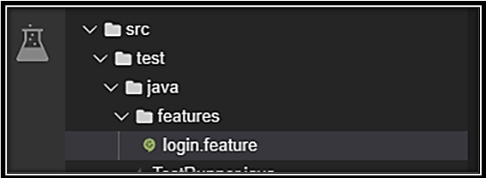
Figure 1: Navigate to src > test > java > features and create the feature file
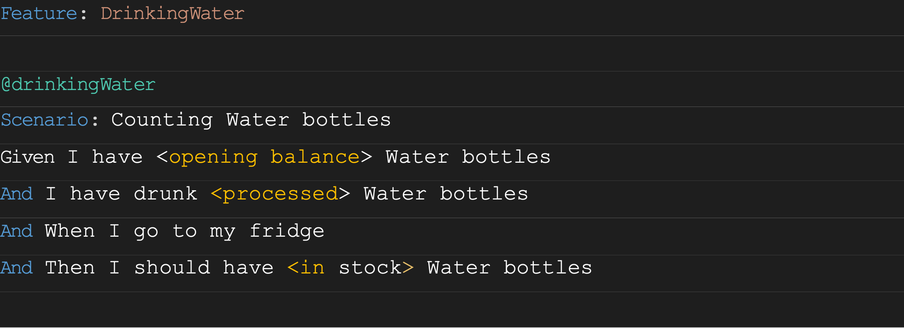
Figure 2: Example feature file content in Web IDE

WRITING TEST SCENARIOS

Web IDE
Create the web test inside the feature file or capture the user journey and refine it in Web IDE.
Helpful step reference: Users can check available reusable steps and keywords here: https://nimbalauto-javadoc.nimbal.co.nz/co/nz/getskills/auto/appsteps/CommonSteps

Example: web login test
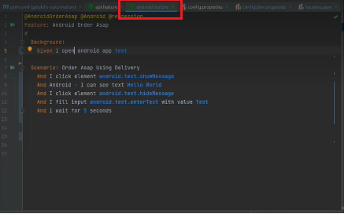
Figure 3: Example login feature file
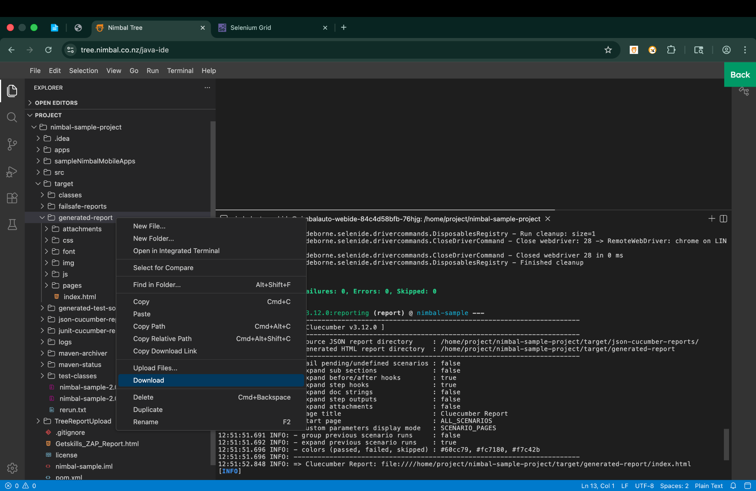
Figure 4: Reference view in Web IDE for writing and refining tests

CONTINUE AI IN WEB IDE
Continue AI helps users understand files, generate or improve test steps, explain failures, and speed up work directly inside Web IDE.

Step 1: Install Continue
1. Open the Extensions panel in Web IDE.
2. Search for Continue.
3. Select the Continue extension and click Install.
4. After installation, the Continue icon appears in the left sidebar.
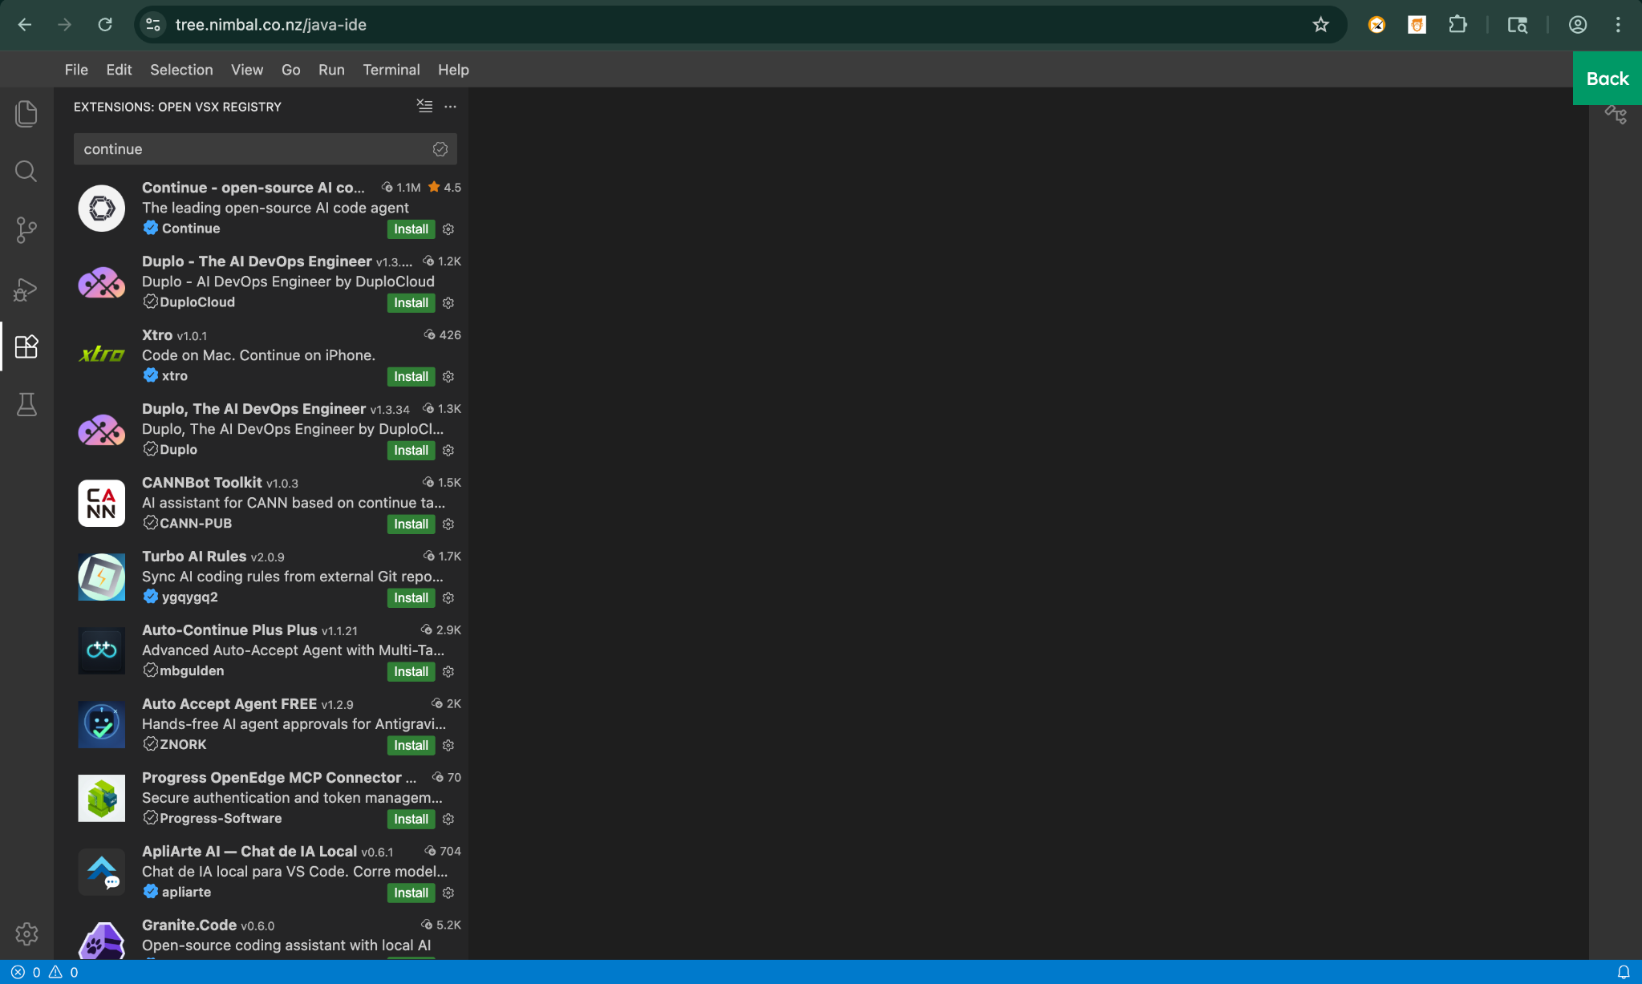
Figure 5: Search and install Continue from the Extensions panel

Step 2: Set up the model
1. Open Continue from the left sidebar.
2. Go to Models.
3. Set up the Chat model first. You can also configure Autocomplete and Edit later.
4. Choose the provider or local configuration that your environment supports.
5. After setup, return to the main Continue chat panel.
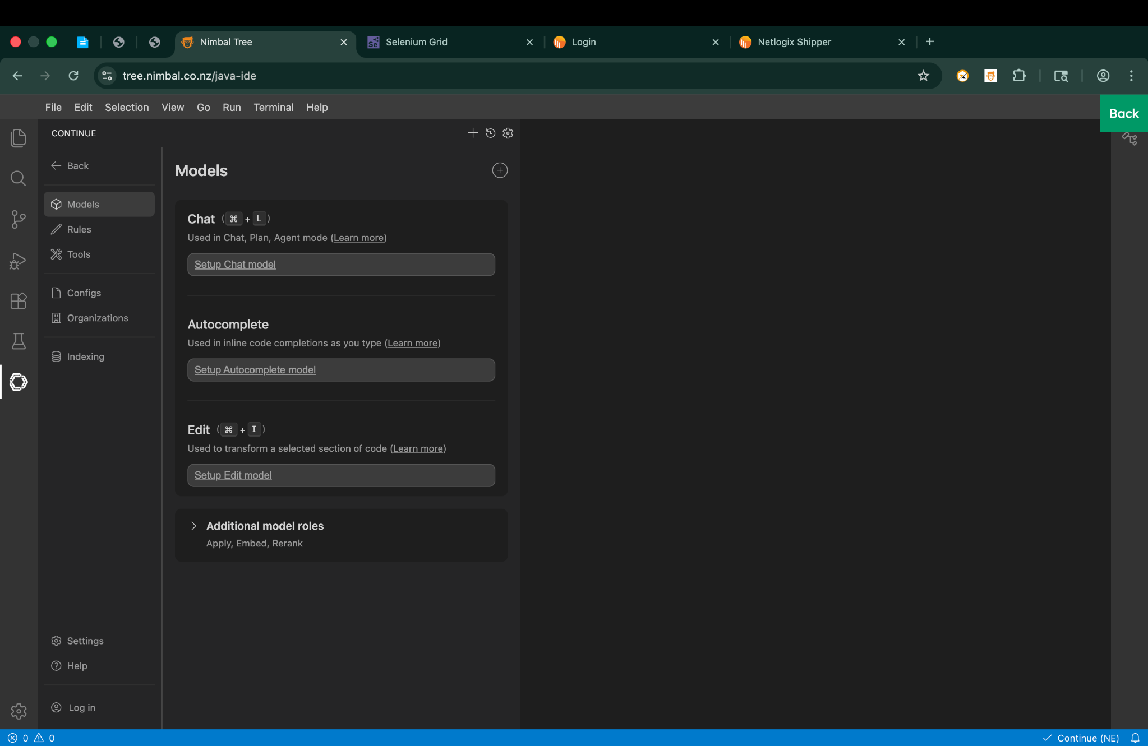
Figure 6: Continue model setup screen in Web IDE

Step 3: Use Continue in chat
1. Open the Continue chat panel.
2. Select the model if it is not already selected.
3. Ask clear prompts about the current feature file, locator, page object, or error.
4. Review the answer before applying changes.
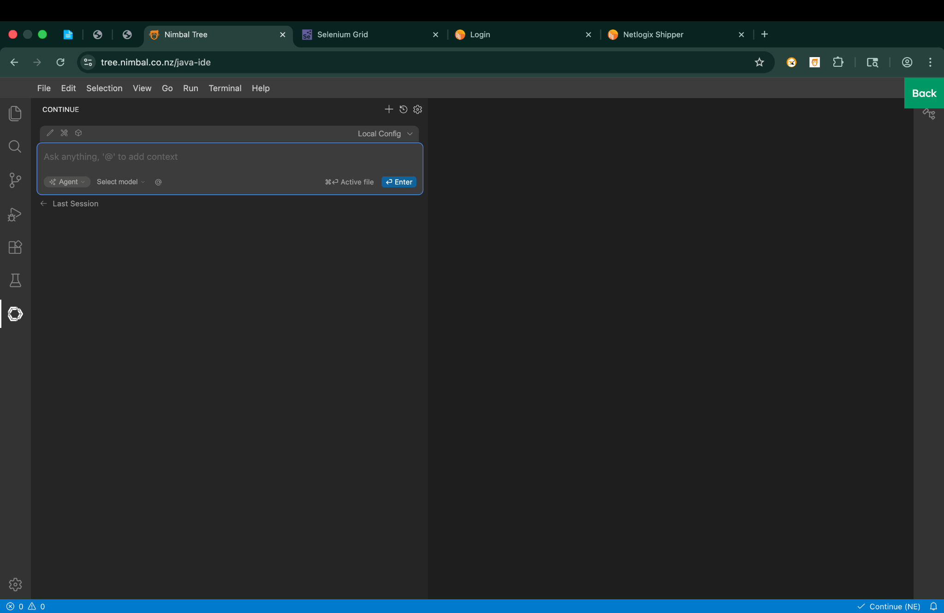
Figure 7: Continue chat screen in Web IDE

Good example prompts
Use case | Prompt example
Understand a scenario | Explain this .feature file in simple steps.
Generate steps | Create Java step definitions for this login scenario.
Fix locator | Suggest a more stable locator for this element.
Debug failure | Explain why this test failed and what to check next.
Improve documentation | Convert this technical flow into user-friendly notes.

Important notes
- Use Continue for guidance and productivity, but always review the output before using it in real tests.
- Keep prompts specific. Mention the file type, expected result, and current issue.
- Do not paste sensitive secrets into chat messages.

USING PARAMETERS AND LOCATORS
For web testing, locator values are usually added in /home/project/src/test/resources/locators.json. Use stable visible locators so the test interacts with the correct web element.

Best practice
- Prefer stable IDs, names, or clear CSS selectors when available.
- Avoid fragile locators that depend on dynamic structure.
- Validate the locator against the live page before running long test flows.
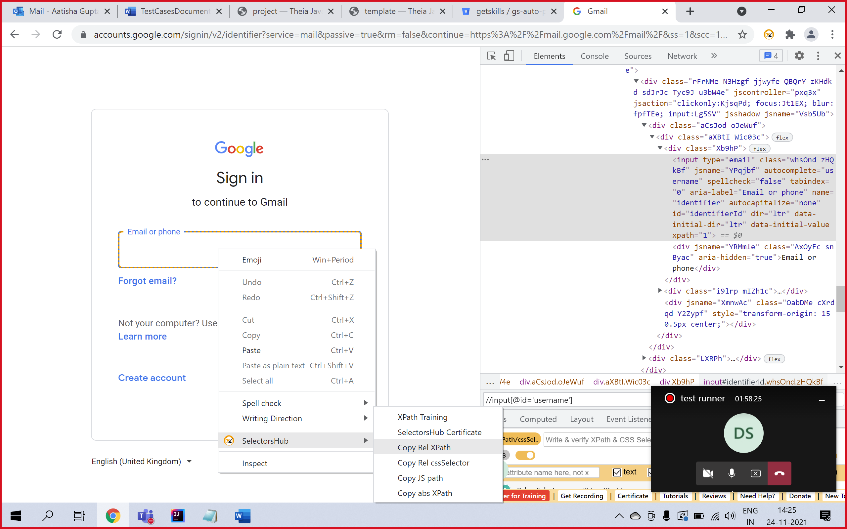
Figure 8: Example of choosing XPath using SelectorsHub or browser inspection
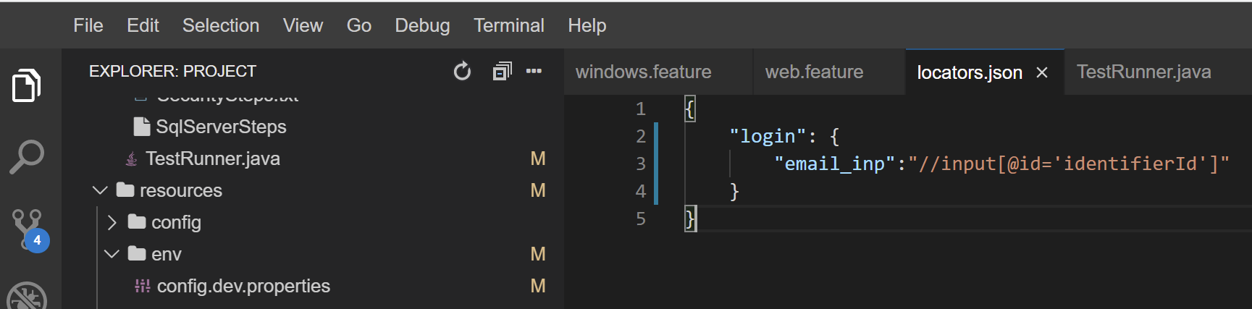
Figure 9: Example locator entry in locators.json

VIEWING TEST REPORTS AND REFERENCES

Viewing test reports
After a test run finishes, the result files are generated inside the target folder of the project.
Main report for users: target/generated-report/index.html
- Total features and scenarios executed
- Passed and failed steps
- Step-by-step execution details
- Screenshots attached during execution
- Failure messages and error summaries
If the test fails, also check: target/generated-report/attachments/
This folder contains screenshots and HTML attachments captured during failure.
Other useful report files
- target/junit-cucumber-reports/cukejunit.html – simple HTML summary report
- target/json-cucumber-reports/cukejson.json – useful for technical integrations and analysis
- target/rerun.txt – contains failed scenarios that can be rerun
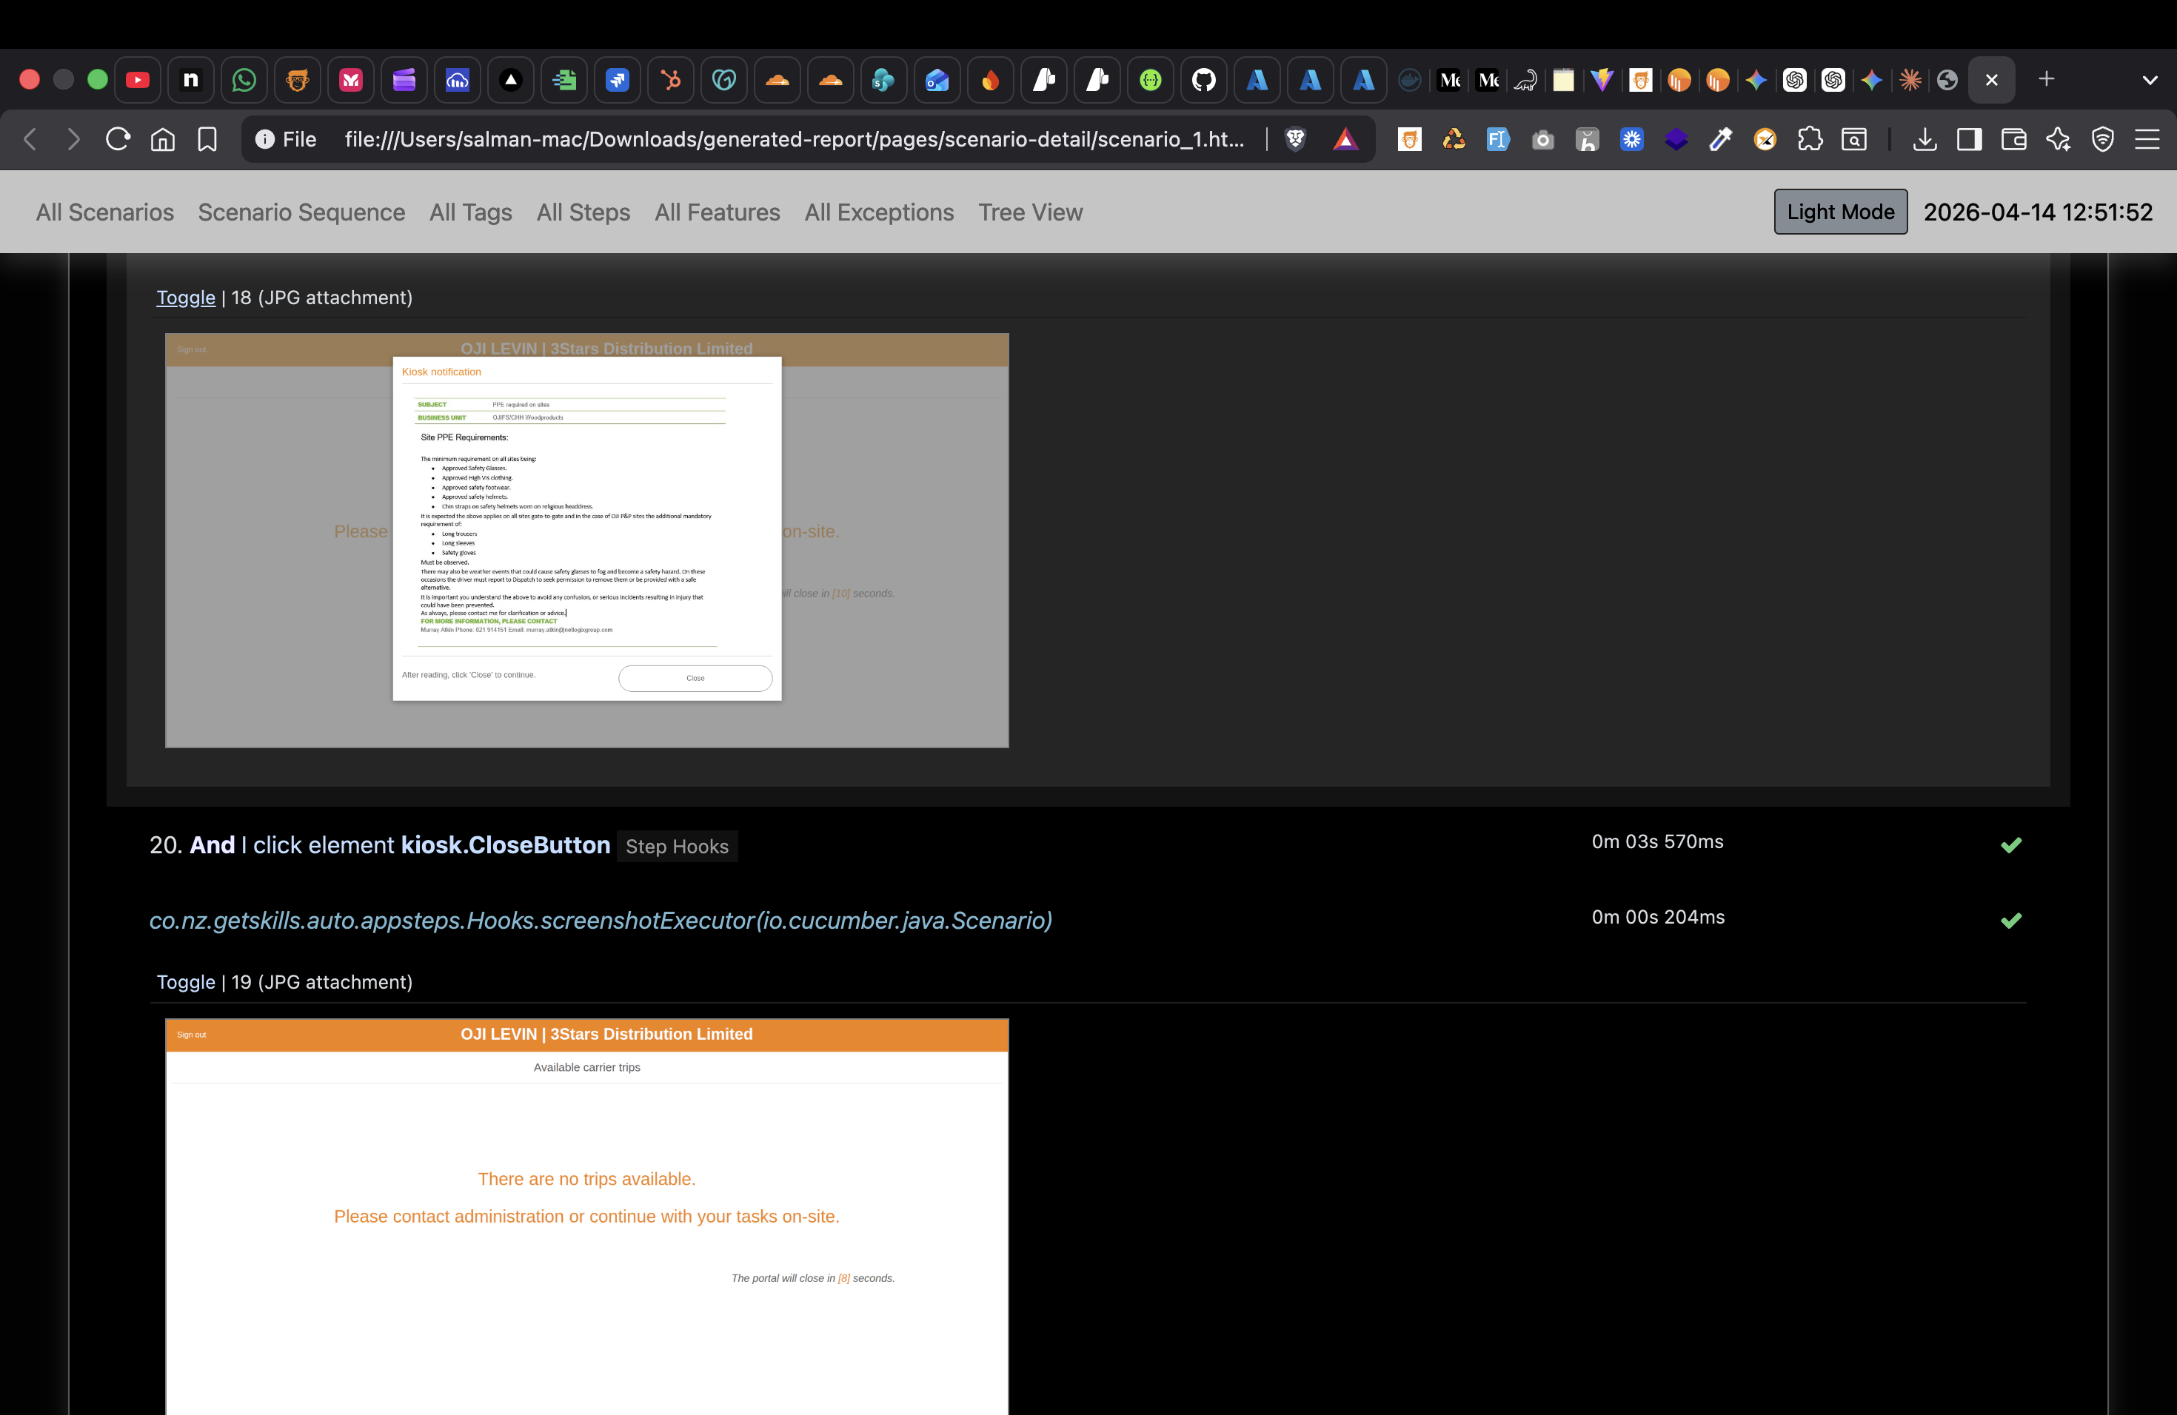
Figure 10: Example test report view
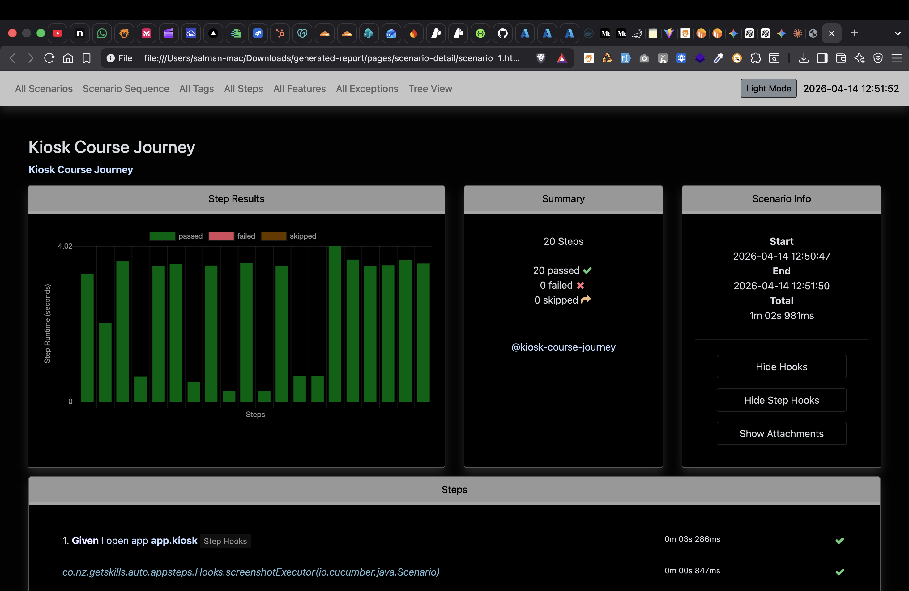
Figure 11: Example user journey or summary report

How to check pass or fail
1. Run the test from the IDE or test runner.
2. Wait until execution completes.
3. Open target/generated-report/index.html.
4. Check the scenario status.
5. If failed, open the scenario details and review the screenshot and error message.

If the test failed
1. Open target/generated-report/index.html.
2. Open the failed scenario.
3. Read the failed step name.
4. Open the screenshot from the attachments section.
5. If available, open the attached HTML page source.
6. Check whether the application was on the wrong screen, the locator did not match, the element was hidden or disabled, or the test data caused a different flow.

USEFUL LINKS
- Nimbal Tree: https://tree.nimbal.co.nz/
- AI Web IDE guide: https://nimbalai.nimbal.co.nz/ai-web-ide
- User Journey guide: https://nimbalai.nimbal.co.nz/user-journey
- Common Steps reference: https://nimbalauto-javadoc.nimbal.co.nz/co/nz/getskills/auto/appsteps/CommonSteps
- Support email: support@nimbal.co.nz
- Company website: https://www.nimbal.io

